



**Adult Census Income Prediction**

PROJECT ARCHITECTURE

01.12.2021

**─**

Project By:

Hrishik V

**Architecture**

Proposed Methodology

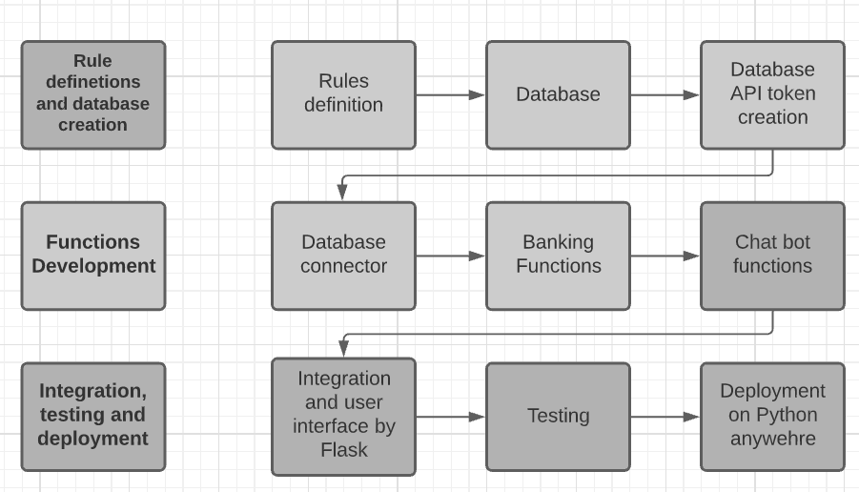

## 3. Architecture Description

### 3.1 Rule **definitions and database creation**

The rules are created with Watson bank assistant by IBM as the reference. The rules are stored in json format for easy access as they can be parsed into dictionaries. The database is created randomly using pythons and stored in csv format which is later uploaded to Astra datastax which is a cql based web hosting service for datasets.

### 3.2 Functions **development**

This step includes development of functions for the individual sections of the chat bot such as connect to the dataset, dataset handling functions and the basic chat bot functions.

### 3.3 Integration **testing and deployment:**

This step contains all other necessary steps as well as integrating the results of all the other steps getting the final product and testing to make sure there are no errors. The integration is done and the front end is designed and developed using flask. The app is deployed locally during the testing phase later on it can be deployed on python anywhere, Heroku or similar services.